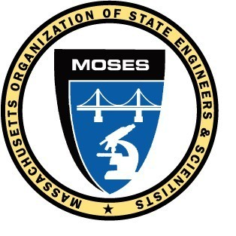
M.O.S.E.S.
GENERAL MEMBERSHIP MEETING NUMBER 416
Tuesday, March 12, 2024
Publick House, Sturbridge
And remote via webinar

President Russell called the 416th MOSES General Membership meeting to order at 7:00 pm and introduced the procedures to be used during this hybrid in-person / remote webinar.

There were 60 members on the webinar and 57 in-person members present for a total of 117 members in attendance.

President Russell appointed Jessica Leger as the moderator for this meeting, Tom Prendergast as the Seargent at arms, and MOSES Attorney Catherine Costanzo as the Parliamentarian.

The Board of Directors minutes from the March 12th meeting were read.

The General Membership meeting minutes from the February 13, 2024 meeting were read. MOTION by Tom Prendergast / Allen Bondeson to accept the meeting minutes as amended that PASSED.

The Treasurer’s report for February 2024 was presented by Treasurer Leger.
MOTION by Tom Prendergast/ Joe Dorant to accept the February 2024 Treasurer’s report that PASSED.

There was no correspondence to or from MOSES this month.

The Commonwealth Collective Bargaining committee report was presented by Co-Chair Jessica Leger and President Russell.

The MassDOT Collective Bargaining committee report was presented by President Russell.

The MWRA Collective Bargaining committee report was presented by Chairman Russell.

President Russell gave the administrative report with topics that included;
- MassDOT members received their initial longevity payments. MOSES is working to resolve the 40 or so members that we know about who did not receive the payment as expected.
- Health Care Mitigation forms for reimbursement of out-of-pocket medical expenses will be available soon. The H&W MOSES Trustees expect the rate to be set at $300 per member.
- Miscellaneous - Tuition remission, DPH South Street construction issues continue, PFML top off provision is now available, there are new procedures for Recreation committee events.

OLD BUSINESS: None

NEW BUSINESS: None

GOOD OF THE ORDER
There were four $50 gift cards raffled off to those present in person at the meeting using proceeds from the MOSES credit card points. The winners of the gift cards are;
Joe Bellino, DEP Arthur Resca, DOT
Mary Matys, DEP Danny Lee, DLS

MOTION to adjourn by Allen Bondeson / Paula Davison that PASSED.

The meeting adjourned at 8:41p.m.

Respectfully submitted,

Allen Bondeson, MOSES Secretary

