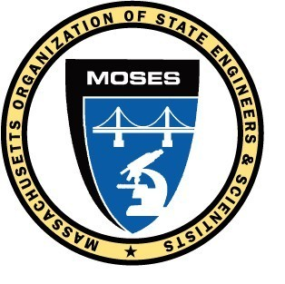
M.O.S.E.S.
GENERAL MEMBERSHIP MEETING NUMBER 415
Tuesday, February 13, 2024
Remote via webinar

President Russell called the 415th MOSES General Membership meeting to order at 7:05 pm and introduced the procedures to be used during this hybrid in-person / remote webinar.

There were 106 members on the webinar.

Jessica Leger was the on-line monitor for this meeting and MOSES Attorney Catherine Costanzo was the Parliamentarian.

The Board of Directors minutes from the February 13th meeting were read.

The General Membership meeting minutes from the January 9, 2024 meeting were read. MOTION by Tom Prendergast / Allen Bondeson to accept the meeting minutes that PASSED UNANIMOUSLY.

The Treasurer’s report for January 2024 was presented by Treasurer Leger.
MOTION by Allen Bondeson / Tom Prendergast to accept the January 2024 Treasurer’s report that PASSED.

Correspondence to and from MOSES was read.

The Commonwealth Collective Bargaining committee report was presented by Co-Chairs Jessica Leger and John Bardzik.

The MassDOT Collective Bargaining committee report was presented by Co-Chairs Allen Bondeson and Nick DelVento.

The MWRA Collective Bargaining committee report was presented by Chairman Russell.

President Russell gave the administrative report with topics that included;
- Health and Welfare offers a $5,000 death benefit. Please notify the MOSES office if you are aware of the death of a MOSES member.
- Health Care Mitigation forms for reimbursement of out of pocket medical expenses will be available soon. The reimbursement is anticipated to be greater than last years amounts of $200 for MWRA and MassDOT employees / $250 for Commonwealth employees
- DPH South Street construction issues continue. The construction issues while employees are still working in the building have created workplace safety issues with regard to dust and noise.

OLD BUSINESS: None

NEW BUSINESS: None

GOOD OF THE ORDER
None

MOTION to adjourn by Tom Prendergast / Allen Bondeson that PASSED.

The meeting adjourned at 8:45 p.m.

Respectfully submitted,

Allen Bondeson, MOSES Secretary

