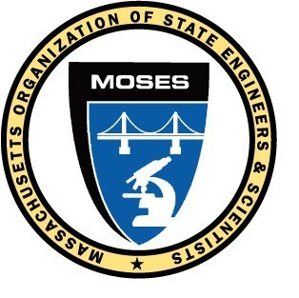
M.O.S.E.S.
BOARD OF DIRECTORS MEETING
Tuesday, December 13, 2022
Segregansett Country Club, Taunton, MA
and remote via Zoom video conferencing

President Russell called the meeting to order at 9:54 a.m. This is the 33rd board meeting using video conferencing with a hybrid in-person / remote meeting format.

Newly elected MOSES Directors were invited to attend this meeting as non-voting participants.

Mr. Baker, Mr. Bellino, Mr. Hanson and Mr. Mulvey were not present at this meeting.

President Russell appointed Joe Dorant as Sergeant at arms and MOSES Attorney Catherine Costanzo as Parliamentarian.

The Board of Directors meeting minutes from the November 9, 2022 meeting were read.
MOTION by Mr. Dorant / Ms. Baker to accept the Board of Directors meeting minutes that PASSED UNANIMOUSLY.

The General Membership meeting minutes from the November 9, 2022 meeting were read.

There was no correspondence this month to or from MOSES.

The Treasurer’s report for November 2022 was presented by Treasurer Galvin.
MOTION by Mr. Prendergast / Mr. Brum to accept the Treasurer’s report that PASSED.

The following committee reports were given;
Commonwealth Collective Bargaining – Mr. Bardzik and Ms. Leger, Co-Chairs
MassDOT Collective Bargaining – Mr. DelVento and Mr. Bondeson, Co-Chair
MWRA Collective Bargaining – President Russell, Chair
Budget Committee – Mr. Bardzik, Chair
Legislative Committee – Mr. Dorant, Chair
Recreation Committee – Ms. Baker, Co-Chair
Health and Welfare Trust – Ms. Leger and Mr. Hurley, Co-Chairs
Goodwill Committee – Mr. Bardzik, Chair
Grievance Committee – Ms. Costanzo, MOSES Attorney
GIC Insurance Committee – Mr. McCullough, Chair

MOTION by Mr. Prendergast / Mr. Galvin to go into executive session to discuss MOSES personnel issues.
MOTION PASSED

The Board went into executive session from 1:20 PM to 2:00 PM.
Ms. Costanzo, and all newly elected board members left the meeting.
The public outcome from the executive session is as follows;
MOTION (20221213ES-1) to accept the recommendation of the Wage Equity committee and provide pay increases to MOSES non-care employees as follows;
3% pay raise to MOSES non-CARE employees effective the first pay period in July, 2022
3% pay raise to MOSES non-CARE employees effective in the first pay period in January, 2023
MOTION PASSED UNAMINOUSLY

MOTION (20221213ES-2) to accept the recommendation of the Wage Equity committee and provide MOSES non–CARE employees bonuses at the discretion of the President in the amount of $3,050 in the aggregate for employees Bob Danilecki, Susan Mariano, Steve Smalley and Janet Vitiello.
MOTION PASSED UNAMINOUSLY

President Russell gave his administrative report.

OLD BUSINESS: None

NEW BUSINESS: None

GOOD OF THE ORDER none

MOTION by Mr. Brum / Mr. Prendergast to adjourn that PASSED.
The meeting adjourned at 2:41 p.m.

Respectfully submitted,

Allen Bondeson,
MOSES Secretary

