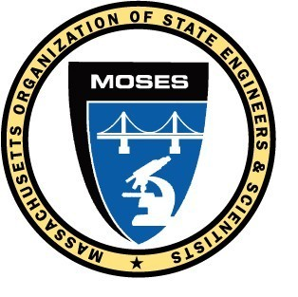
M.O.S.E.S. MONITOR
August 2014

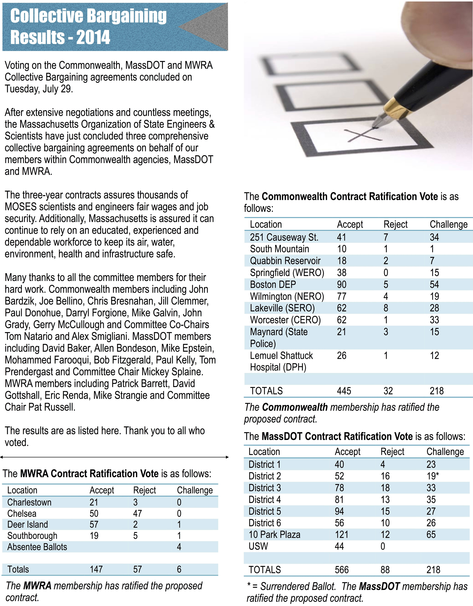
President’s Message
After more than 6 months of tough negotiations with the MWRA, the Commonwealth and MassDOT, all three Collective Bargaining Committees reached tentative agreements with management and all were ratified by the membership before the end of the month.

I need to thank all the committee members of the various collective bargaining teams for their hard work especially the Chairs and Co-Chairs of each committee for their dedication and commitment to getting the jobs done. Pat Russell, MWRA Chair, Co-Chairs Tom Natario and Alex Smigliani for the Commonwealth and Mickey Splaine for MassDOT delivered contracts that the membership can be proud of. I also need to recognize the outstanding guidance the MOSES legal staff has given to the committees. Ann Looney and Paul Donohue for the Commonwealth, Jim McDonagh and Eric Klein for MassDOT and Jim McDonagh for MWRA; this left Michelle Gates holding down the fort in the office juggling hearings, arbitrations and responding to the membership’s needs. Negotiations are a time consuming project and without a full team effort of the legal staff we would not be as prepared as we were. Last but certainly not least, I need to thank our administrative support team, Janet Vitiello, Joanne Bremer and Greg Ringdahl without them the ratification could not have happened.

As the 2013- 2014 legislative session comes to an end MOSES has been successful on many fronts.

- A priority bill for MOSES that provides OSHA protections for state employees passed the legislature and signed by the Governor on June 26, 2014.
- We prevented H-59 from passing; a bill that would have drastically reduced our retiree healthcare benefits. Without the membership support and actions, this would have never been possible.
- We actively lobbied to pass many transportation bond bills that provided millions of dollars to our transportation agencies.
- We have successfully worked to increase funding to the Crime Lab and worked to add a MOSES seat to the Forensic Science Advisory Board.
- Our amendments to the budget over the last two years have restored some of the funding lost during the hard economic hard times. The environmental budget alone was increased $16 million dollars over last year’s amount.
Thank you to all the members who helped make this a successful legislative year for MOSES.
At several meetings in the past few months, those in attendance heard from candidates for state office. At the May board of directors meeting the board listened to presentations from Steve Grossman, candidate for Governor, and from Deborah Goldberg and Barry Feingold, candidates for Treasurer. At the evening meeting Don Berwick, candidate for Governor spoke. Previously other candidates have spoken to either the board of directors and or membership, among them Warren Tolman, candidate for Attorney General, Leland Chung and Mike Lake, candidates for Lt. Governor, Tom Conroy, candidate for Treasurer, and Joe Avellone, former candidate for Governor. Martha Coakley, Candidate for Governor, spoke at the June board meeting. The board of directors accepted the legislative committee’s recommendation to endorse Warren Tolman for Attorney General and Tom Conroy for Treasurer. Both candidates are strong labor supporters and have either supported or filed MOSES legislative initiatives. This will be an important election year as the governor has decided not to run for re-election and there are many open seats in the legislature.

MOSES members again turned out to judge the state science and engineering fair for high school students. The knowledge and aptitude of the students is encouraging in that our scientific and engineering future will be in good hands. Thank you for your continued participation and support of the students and program.

Over the last six months three board of directors from MassDOT have retired Tom Ockerbloom (D5), Tom McGuire(D5) and Paul Hoey (D3) , and one from DPH(SLI), Ed Corkren; congratulations to them all and thank you for the work and time you have given to the membership and to MOSES. Also DCR saw former BOD and Steward Dominic Pezzuto retire; Dominic for many years served as Co- Chairman of the Grievance Committee and was always the first to champion the workers and MassDOT had Norm Goldman, former BOD, steward and DOT grievance chairperson retire. This October MOSES election will be held for all seats, please think about running for office and serving your fellow members. Enjoy the remainder of the summer. – Joe

MOSES 2014 ELECTION OF OFFICERS

The biennial election of MOSES officers is scheduled for this fall. The MOSES Election Committee will take nominations at the Tuesday, October 14, 2014 General Membership Meeting in Malden, MA.
As usual, our at large offices will be up for election, these include President, Vice-president, Secretary, and Treasurer as well as three Trustee seats. All officers will serve a two year term which begins at the December 9, 2014 General Membership Meeting. Nominations will also be taken for 2 year Board of Director positions representing the following agencies:

Dept of Transportation  Dept of Environmental Protection  Dept of Public Health  Mass Water Resources Authority  Dept of Labor  Dept of Labor & Workforce Development  Office of Attorney General  Dept of Fish & Game  Dept of Conservation & Recreation  Exec Office of Environmental Affairs  Div of Energy Resources  Dept of Agricultural Resources  Dept of State Police  Dept of Public Safety  Governor’ s Highway Safety Bureau  Dept of Fire Services  Chief Medical Examiner’s Office | 12  6  3  3  1  1  3  1 | Dept of Mental Health  Dept of Development Disabilities  Chelsea Soldiers Home  Holyoke Soldiers Home  Exec Office of  Health and Human Services  Dept of Admin & Finance (DCAM)  Bureau of State Office Buildings  Dept of Housing & Community Develop  Mass Emergency Mgt Agency  Other Agencies including  Dept of Corrections  Dept of Revenue  Dept of Public Utilities  Military Division  Active Retirees (Non-Voting Seat) | 1  1  1  1  1
Directors are elected by members from their respective agencies

The election will be administered by True Ballot, Inc.® under the supervision of the Election Committee.
Candidate Information
All MOSES members who have been in good standing since October 14, 2013 can be nominated. MOSES is a member run organization and all members are encouraged to consider running to serve their fellow employees.
Candidates must be present at the meeting, or must submit a letter or email stating his/her willingness to serve if elected. Letters or emails should be directed to the Election Committee and must be received before the closing of nominations. These letters can be sent to the
90 North Washington St. Suite 3
Boston, MA 02114,
or emailed to MOSESELECTION@MOSES-MA.ORG, or faxed to 978 352-6378.
Any questions can be referred to the Election Committee by email at moseselection@moses-ma.org or by calling 617 367-2727.
Voter Information
All members in good standing are eligible to vote in the biennial election. Ballots will be mailed to each member’s last known address. Please contact us at 617 367-2727 if we do not have your or some other MOSES member’s correct address. This may include those who have recently moved or otherwise changed their address. Please let us know if there is someone who is not receiving their MOSES Monitor. The committee uses address information provided by the employer and it is the committee’s goal to use the most accurate information available.
Voting lists will be developed from the list of active employees provided by the employers at the end of September 2014. Active Retirees will be mailed ballots at the address shown in the MOSES membership committee’s database.
This year the Election Committee consists of Bob Danilecki, Retiree (DHCD), Chairman; Louis Sciortino, Retiree (MDC); Arne Carr, Retiree (FWE); Paul Petrowski, Retiree (DOL); Norman Goldman, Retiree (MassDOT); with two Alternates Chuck Salemi, Retiree (DPH); and Paul Hoey, Retiree (MassDOT). Again if you wish to contact the Election Committee email moseselection@moses-ma.org .
Watch the MOSES Monitor and the MOSES web page for updates on Election news and schedules.

MOSES WELCOMES NEW EMPLOYEE
The next time you call the MOSES office you may have a new voice answering the phone. Please welcome Gregory Ringdahl. Greg was recently hired for the Administrative Coordinator of Membership Services and Outreach position at M.O.S.E.S. Mr. Ringdahl received a Bachelor of Social and Behavioral Sciences in Legal Studies from the University of Massachusetts Amherst. We are sure he will be a great asset to the organization.

HAVE YOU MOVED?
During the contract ratification votes the poll workers noted that many of the challenged ballots voted were because people had not changed their addresses with the MOSES office. Please call us to update your information at 617-367-2727 or e-mail us through the web page using the contact us e-mail.

NEED A LOAN?
Contact the MOSES Federal Credit Union at 978-276-0750 or e-mail them at mosesfcu@verizon.net.
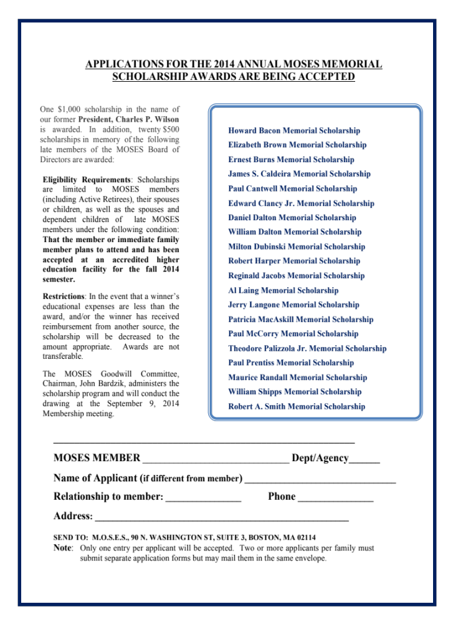
MOSES MONITOR
90 North Washington Street
Boston, MA 02114

SCHOLARSHIP DRAWING SEPTEMBER GENERAL MEMBERSHIP MEETING

September 9, 2014
September General Membership meeting will be held at Wachusett Mountain Ski Area - 499 Mountain Road - Princeton, MA 01541 (978) 464-2300 Directions: From Worcester (20 minutes) Take Rt. 290 East to exit 19 (which is 190 North). Take Exit 5 off 190 North, which will put you onto 140 North. Follow 140 North for approx. nine miles. Take a left onto Mile Hill Rd. and travel 1/2 mile to the Ski Area entrance on the right. From Boston (1 hour) Take Rt. 2 West to Exit 25 for Westminster/Princeton. Take Rt. 140 South to a right onto Mile Hill Rd. and travel 1/2 mile to the Ski Area entrance on the right. From Providence (1 1/4 hours) Take Rt. 146 North to Rt. 290 East to Rt. 190 North. Take Exit 5 Rt. 140 North nine miles to a left onto Mile Hill Rd. and travel 1/2 mile to the Ski Area entrance on the right. From Hartford, CT (1 1/2 hours) Take Rt. 84 East to the Mass Pike East to Exit 10 Auburn to Rt. 290 East to Rt. 190 North to Exit 5 Rt. 140 North nine miles to a left onto Mile Hill Rd. and travel 1/2 mile to the Ski Area entrance on the right From Nashua, NH (1 1/4 hours) Take Rt. 130 West to Rt. 13 South to Rt. 2A West to Rt. 140 South or Rt. 3 South to Rt. 495 South to Rt. 2 West to Rt. 140 South to a right onto Mile Hill Rd. and travel 1/2 mile to the Ski Area entrance on the right.
October 14, 2014
The October General Membership meeting will be held at Anthony's Restaurant, 105 Canal Street, Malden, MA (617) 321-8900 Directions: From Rte. 128 north or south, take exit 37 onto Rte. 93 south. A little ways down Rte. 93 take Exit 32 onto Rte. 60 east toward Malden. Traveling on Rte. 60 east, pass Fellsway, Highland Avenue, Football stadium (on right) and under MBTA tracks. Then take right turn at Commercial Street. Take first left turn onto Charles Street. Anthony's is at corner of Charles and Canal Street.

